*Directions:  Show all work, and answer each question that is asked.  Explanations should be given in complete sentences.  All graphs should be drawn accurately on this sheet, and be fully labeled.*

1. Earlier in the semester, we found that the cost function for producing $x$ pairs of a particular type of skates was given by: $C(x)=752.75+42.54x$.

What is the inverse of this function? What does it represent?

Pick one ordered pair on the graph of the inverse function, and describe what it tells you about this situation. **Make sure the pair you choose makes sense in context of the problem.**

Use the inverse to determine the number of pairs of skates that can be produced for an initial investment of $15,000.

1. Find the inverse of the function $h(x)=3x^{3}-5$.

Check your answer by performing the composition of the two functions.

1. The graph below shows the percentage of people 25 years and older in the US who have completed a Bachelor’s Degree over a several year period. Call this function $f(t)$, where $t$ is measured in years since 2006.

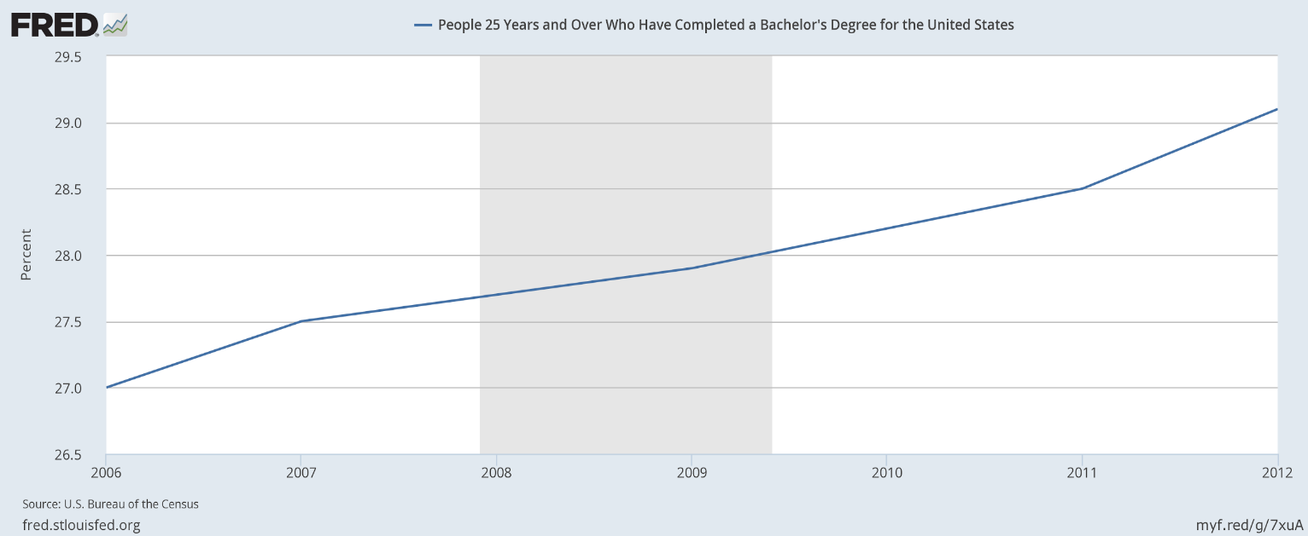

Explain how you know that this function has an inverse function.

Give the domain and range of the inverse function.

Find $f^{-1}(27.5)$ and give a practical interpretation.

1. A sunglass manufacturer finds that consumer demand of a certain line of sunglasses varies based on price. Market studies predict the relationship is approximated by the function $p=f(q)$ graphed below, where *q* represents the quantity of sunglasses sold in thousands and *p* represents the price in dollars.

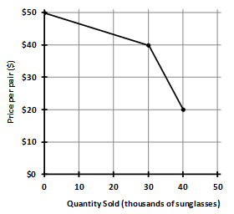

Sketch a graph of the inverse function.

Find and interpret the real-life meaning of $f^{-1}(30)$.